Pump’s flow-rate modeling

From the Pin data (pressure inside the sensorbox), the pump’s flow-rate can be modeled. This process is being theoretically analyzed in the chapter 4.1.2 “Calculating pump’s flow-rate”. In the next chapters this method will be implemented on the real data gathered during the flight.

# Simplifications

For a first order analysis, some simplifications are important. The formula derived from the theoretical analysis is:

Since the duration of the pressurization, which is stage 1, is maximum 2 minutes, Tout and Pout will be considered constant values. The quantity Vin is always constant and according to the data, Tin is also a constant with significant accuracy. Therefore, the flow-rate can be expressed as:

The constant am will vary with the different cycles of the experiment. So in the cycle m, am will be expressed as:

The units will be: Vin [lit], T [K], P [mbar].

Thus, for every cycle, am and Pin derivative have to be calculated. There is no interest in calculating am so the analysis will be focused on the derivative of Pin.

One last important simplification is that the leakage is not taken into account.

# Sensorbox pressure profile

During stage 1, the air is pressurized in the sensorbox and thus the rate of change of Pin is very important for modeling the pump’s behavior.

Among different functions, the one describing the data more efficiently is:

A sampling of four cycles has been selected to focus on. The altitude and the ambient pressure at the beginning of the corresponding cycle are described as initial conditions. The following graphs are presenting the regression fittings of the above function, for initial conditions increasing with the flight time.

Graph 1: Pin modeling during stage 1 with different initial conditions {altitude, Pout}

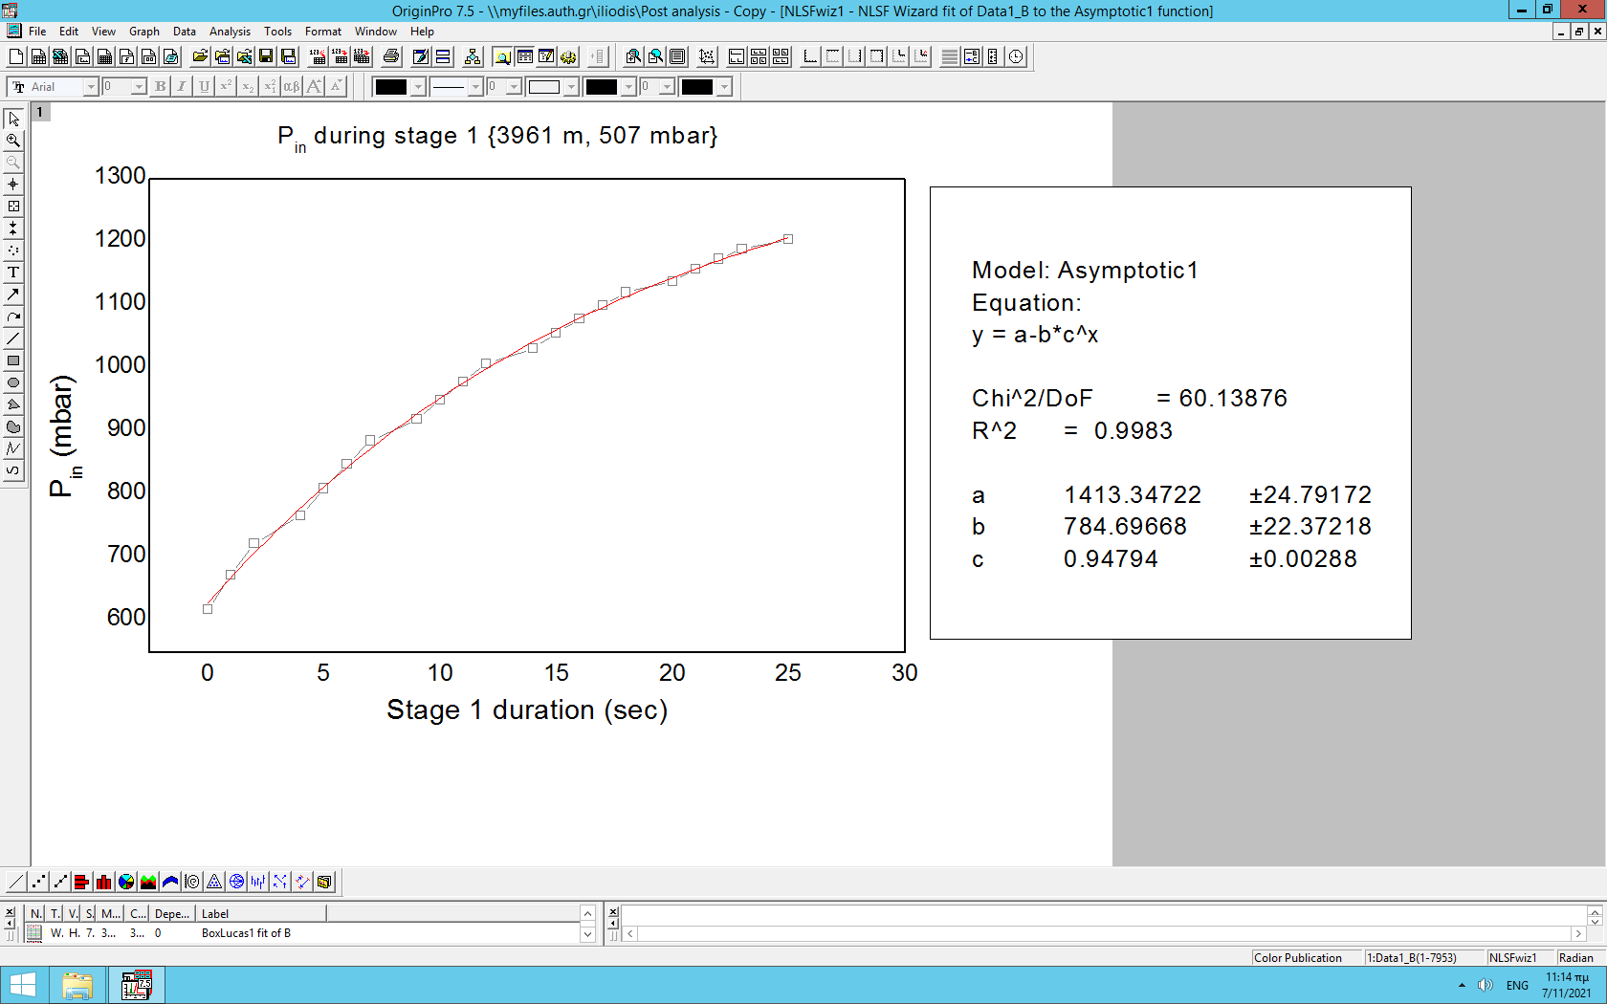

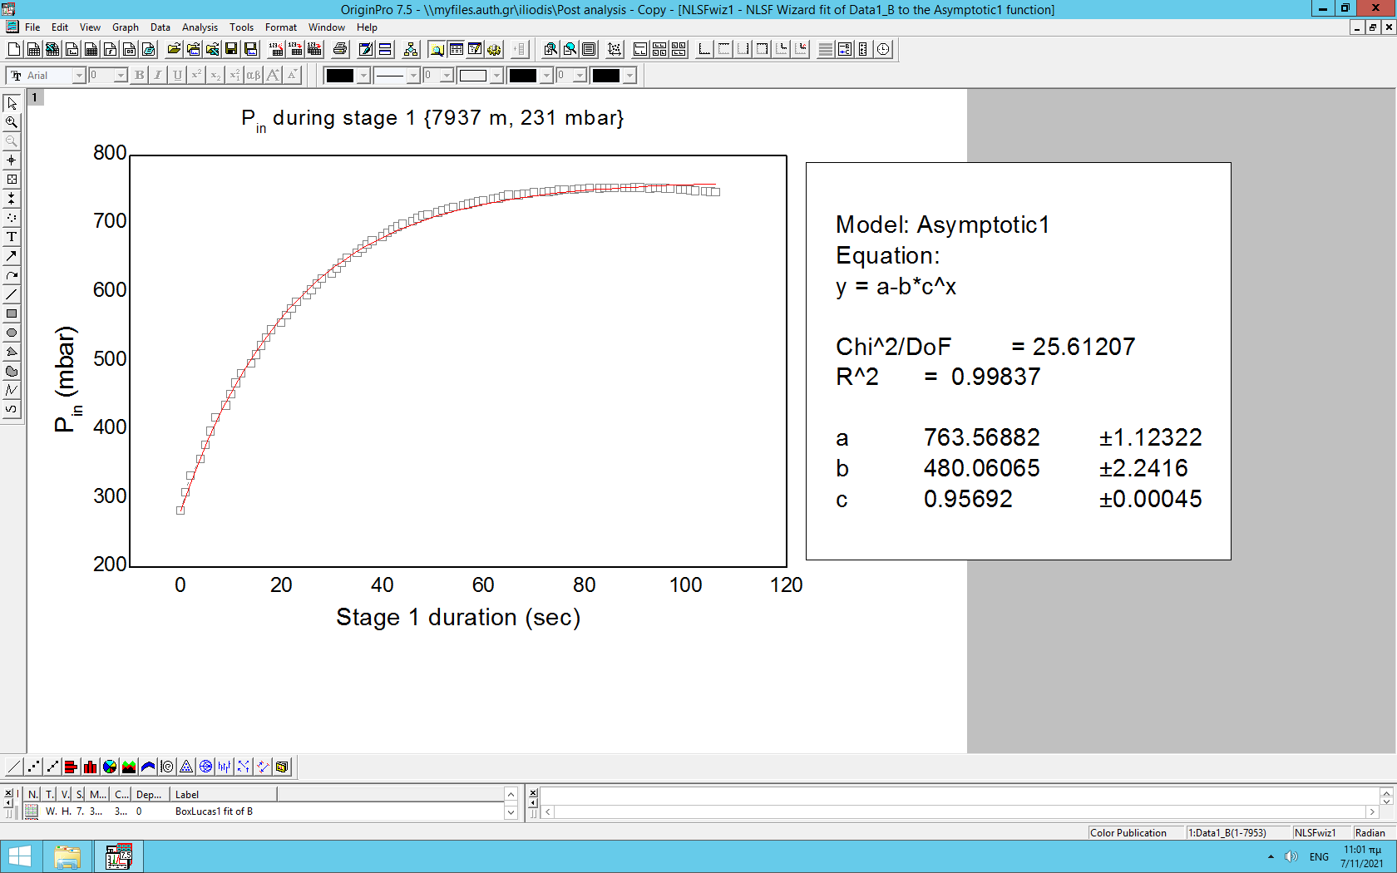

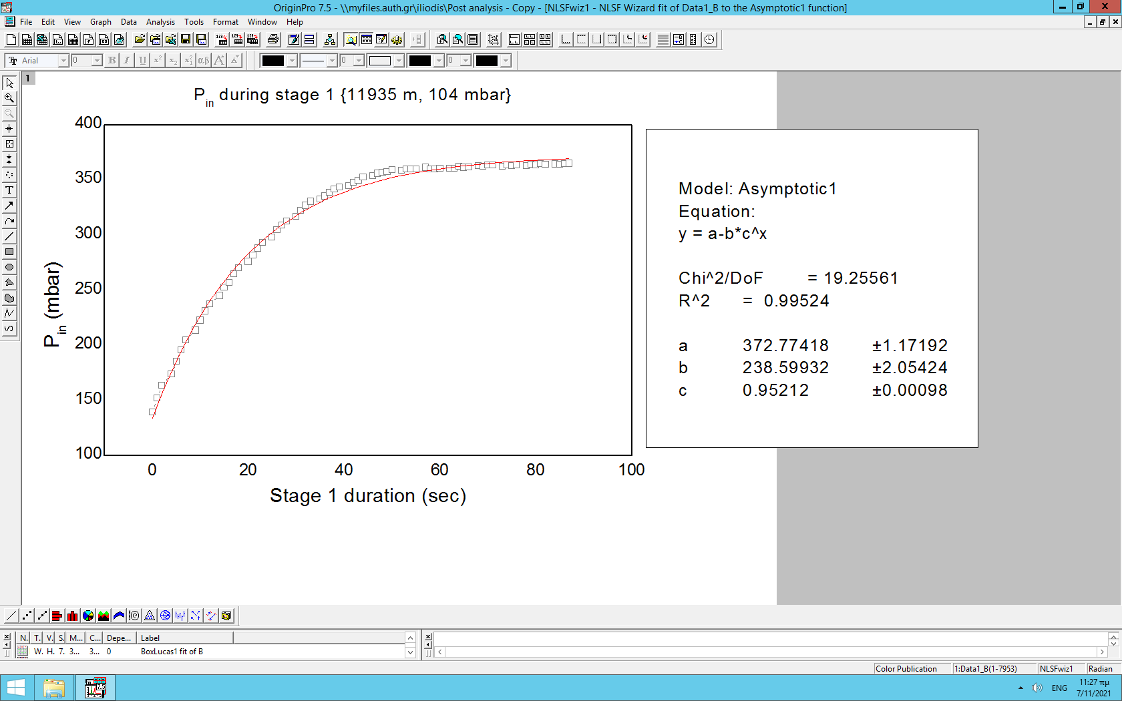

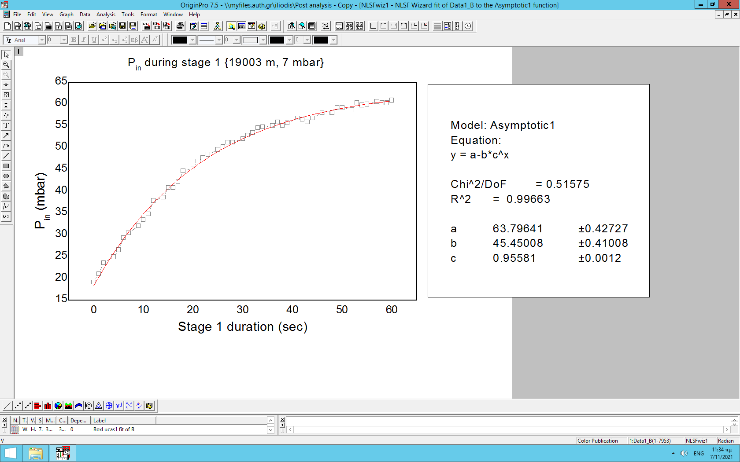

The parameters from the four regression fittings are gathered below.

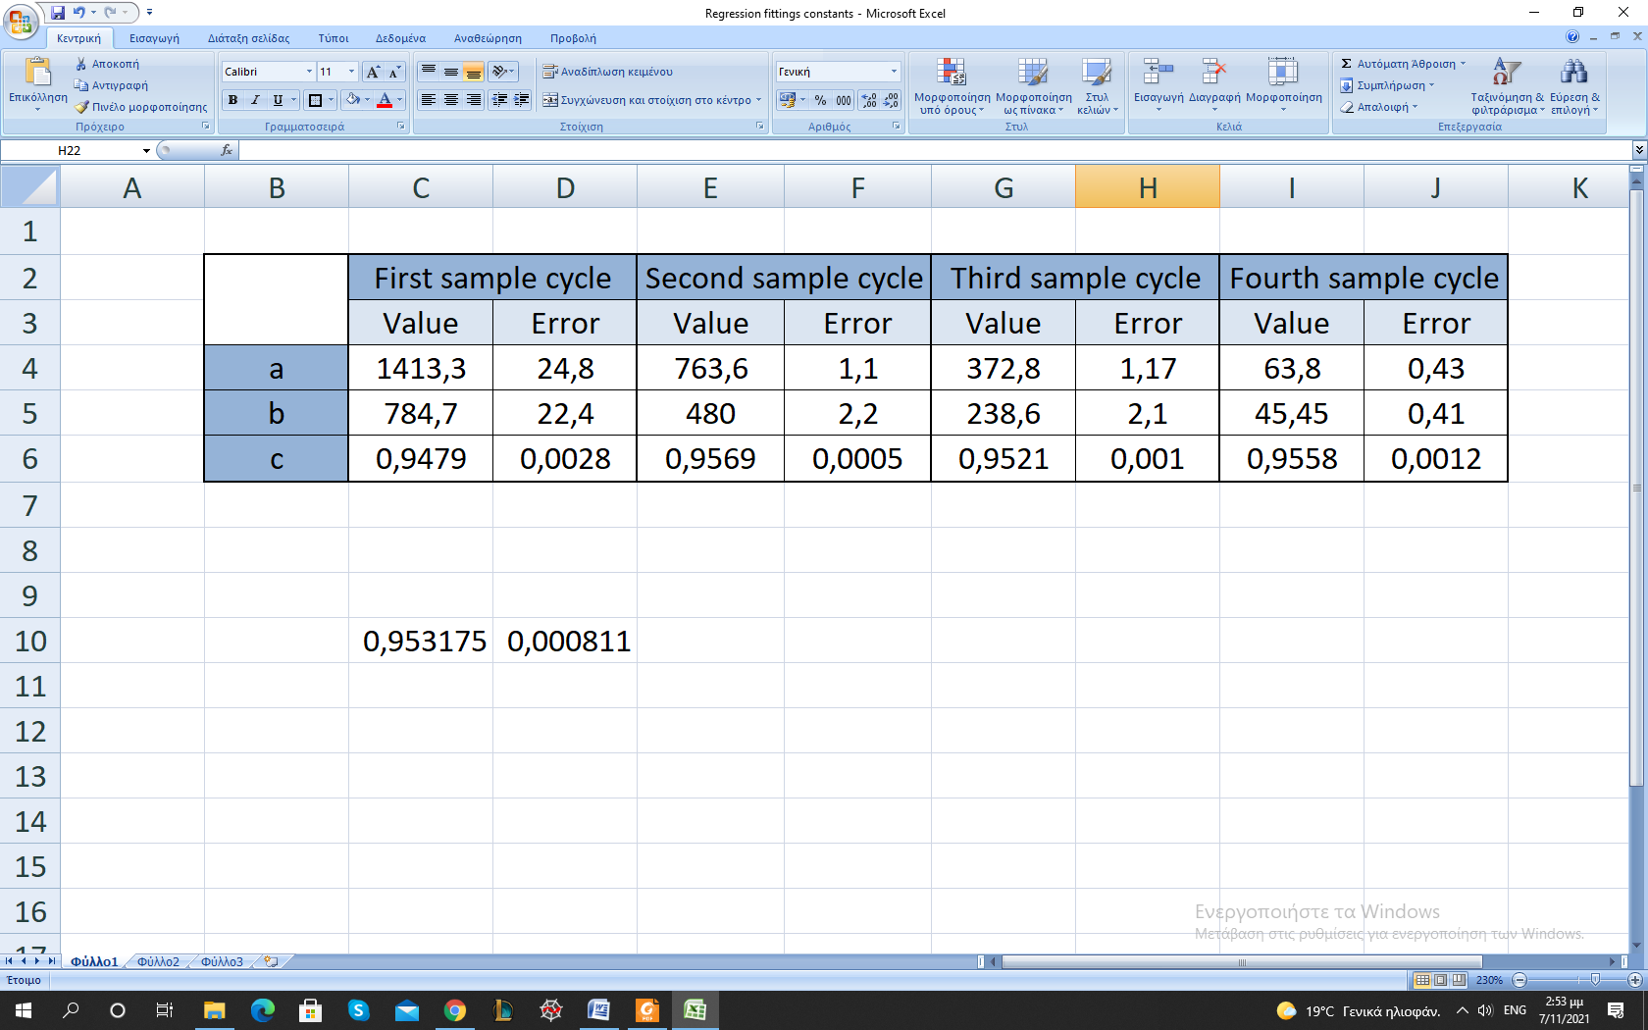

Table 1: Regression fittings parameters

There are some significant results that can be derived by examining this table. First of all, the parameter c is almost constant throughout the different cycles. The mean value of c, which is dimensionless, is:

The fact that this parameter remains constant is implying that there is no dependence on neither the initial parameters, nor the pressure difference (ΔP = Pout – Pin). Thus, this quantity is characterizing the pump’s behavior. The pump will start pressurizing the air into the sensorbox, but after a relatively long time the pressure inside will tend asymptotically to a value, since:

Regarding the other two parameters, a and b, there is a constant decrease.

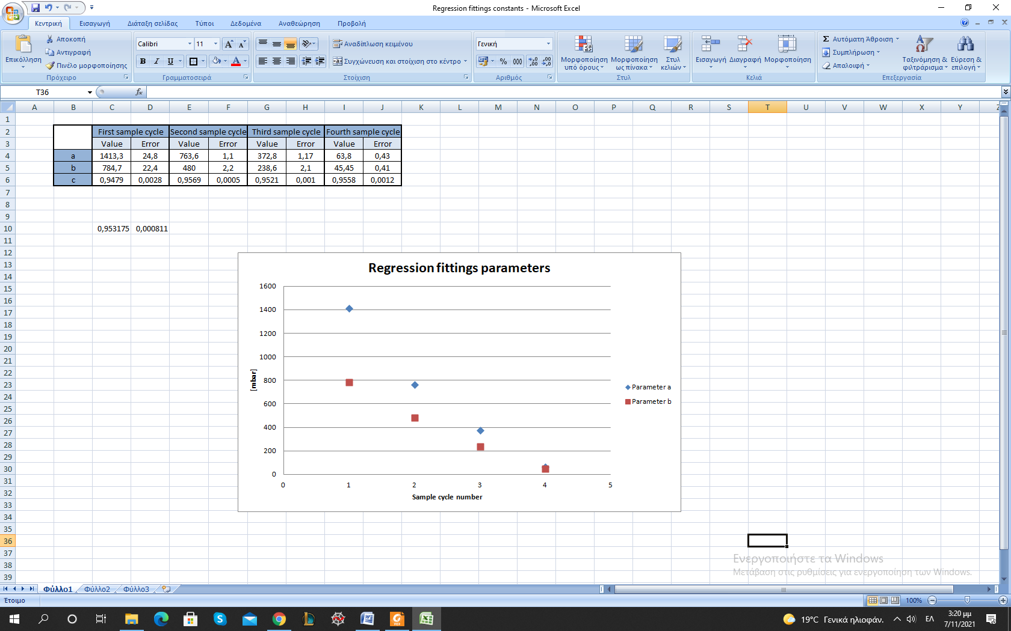

Graph 2: Parameters a and b

These two parameters are not dimensionless, but their units are millibars [mbar]. From their behavior it is clear that they strongly depend on the initial parameters, and especially on Pout. A more detailed examination of their behavior (using all the available data to make regression fittings, then plotting the parameters with Pout and ΔP), could provide more explicit information for their relation with the initial conditions. Yet, these details are not important for the experiment and will be ignored. What is important is their dependence on the initial conditions. Therefore, the regression function can be written as:

where this dependence is being implied with the symbol of the pressure generally.

# Conclusion

Returning to the formula:

and taking all the above into consideration, the flow-rate function can be written as:

or

or

It is explicit that the pump’s flow-rate function tends to zero. Thus, only if the initial conditions are favorable, the pump is able to pressurize the air sufficiently for the experiment’s needs. Considering the ambient conditions, this pump was not the correct choice for the whole flight of this experiment.